COPD Respiratory Review
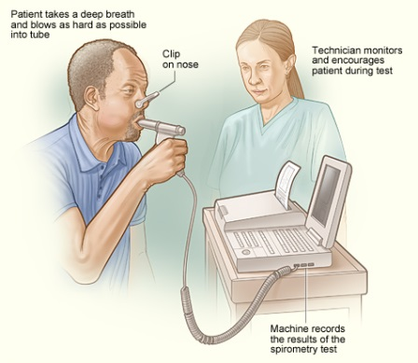
This will involve testing your breathing with a spirometer (similar to as shown above) which you may have used in previous review appointments.
This is done to check that your breathing is good as is possible and to see that you are on the correct medication for your condition.
YOU MUST BE WELL ON THE DAY OF YOUR APPOINTMENT
Please take all your medication (including inhalers) as usual on the day of the test.
PLUS Please also take 4 doses of your blue inhaler (salbutamol or Ventolin) 30 minutes before the appointment through your spacer.
Please ensure you:
- Remove loose fitting dentures
- Remove chewing gum
- Empty your bladder before the test begins
- Bring any inhalers that you have to the test
If you have any of the following please telephone the surgery before your appointment and ask to for a call back with one of our HCA’s for advice:
- A chest infection within 6 weeks of the test requiring antibiotics or steroids
- A heart attack within the last 3 months or unstable angina
- Recent eye surgery
- Abdominal surgery within the last 3 months
- A recent perforated ear drum
- Coughing up blood
- Have fractured ribs or back pain
To improve the accuracy of the test please DO NOT:
- Smoke for 24 hours (ideally) or as long as you can manage prior to the test
- Drink any alcohol for 4 hours before the test
- Eat a heavy meal for at least 2 hours before the test
- Wear tight clothing which would restrict your breathing

